LOCAL EXTREMUM IN THE PROBLEM OF COVERING THE FIELDS BY THE CIRCLES
A.Danilin¹, V.Komyak², A. Pankratov³, V. Patsuk⁴, A.Prikhodko⁵
1,2,5 Kharkiv,National University of Civil Defense of Ukraine, uodscz@nuczu.edu.ua
3,4 Kharkiv, Institute of Problems of Mechanical Engineering of the National Academy of Sciences of Ukraine, impankratov@mail.ru

Abstract: The problem of covering the area by circles, mathematical model of the coating offers a new coverage criteria based on which analytically describes the range of permissible solutions of the problem. Based on the analysis of the properties of the model, it is shown that the solution of the problem can be reduced to the solution of problems of nonlinear programming sequence.
Keywords: circle, coverage criteria, optimization, nonlinear programming

INTRODUCTION
In various industries of the economy there are problems associated with the processing and transformation of geometric information. These problems are referred to a class of optimization geometric design problems [1], which solution as well as the development of their methods is important. This class of problems include the problem of optimal material cutting (both regular and irregular), the problems of building the optimal ways and linking networks, coverage, partition, some scheduling problems, and others. [1 - 7].
THE ANALYSIS OF RECENT RESEARCHES AND PUBLICATIOS
An important class of geometric design problems are problems of irregular covering the field by geometric objects [8], as well as regular [8 – 12]. In the problems of covering it is set up a claim that all points of the field were covered by geometric objects, while the conditions of non-intersection of objects between themselves and their placement in the field may be violated. Results and detailed reviews on given researches are in [13 – 15]. The problems of single covering a limited area by N-circles (such as in a Euclidean metric, and in some other metrics) is also known as the problem of N-centers. For the problem of N-centers in different metrics it is offered a variety of heuristics and algorithms using Voronoy’s regions [16]. Problems of coverage are models of many practical problems. In [17] it is set and solved the problem of interaction between militarized security subdivisions of the railroad and fire-rescue units, which is reduced to covering the area by the circles of different radii. In [18] it is set the problem of the placement optimization for observation points, which arises when designing ground video monitoring systems. The problem is reduced to the problem of covering the area by the circles of variable radii, the value of which depends on the class of fire danger of covered area and its relief. Thus, the important practical problems require to develop the methods of covering the fields by circles of variable radius.
In our article, we propose an approach to obtaining a local extremum of covering problem.
OBJECTIVES
The purpose the article is to build a mathematical model to optimize the placement of variable radius circle and on its basis - the development of methods of solution.

THE MAIN RESULTS OF THE RESEARCH

There is a polygon $P$, defined by a set of vertices $p$, $k=1,2,\text{.}\text{.}\text{.},n$ and a set of circles $C_{i}$, $i=1,2,\text{.}\text{.}\text{.},N$, with varying radius $r_{i}<r$ and centers $v_{i}=(x_{i},y_{i})\text{.}$ Suppose $u=(v_{1},r_{1},\text{.}\text{.}\text{.},v_{N},r_{N})$ – vector of variables, $F(u)$ - the objective function , .
By definition $Ξ(u)$ – coverage of polygon $P$ if $P⊂Ξ(u)⇔Ξ^{'}(u)intersectP=∅$, where $Ξ^{'}(u)=R^{2}\text{\backslash int}Ξ(u)$.
Note 1. In this study, we consider only such coverings, which met the following conditions $\text{int}C_{i}⊄Ξ_{i}(u)$, $Ξ_{i}(u)=\underset{j=1}{\overset{i−1}{}}C_{j}(v_{j},r_{j})\underset{k=i+1}{\overset{N}{∪}}C_{k}(v_{k},r_{k})$ and $\text{int}C_{i}(v_{i},r_{i})intersect\text{int}P≠∅$, $i=1,2,\text{.}\text{.}\text{.},N$.
Problem of circular coverage of polygon. The start point – vector $u^{0}=(v_{1}^{0},r_{1}^{0},\text{.}\text{.}\text{.},v_{N}^{0},r_{N}^{0})$, where $Ξ(u^{0})$ covers a polygon $P$. The task – to determine the vector $u^{}=(v_{1}^{},r_{1}^{},\text{.}\text{.}\text{.},v_{N}^{},r_{N}^{})$, in which $F(u)$ reaches the extreme and $Ξ(u^{})$ is coverage of a polygon $P$.

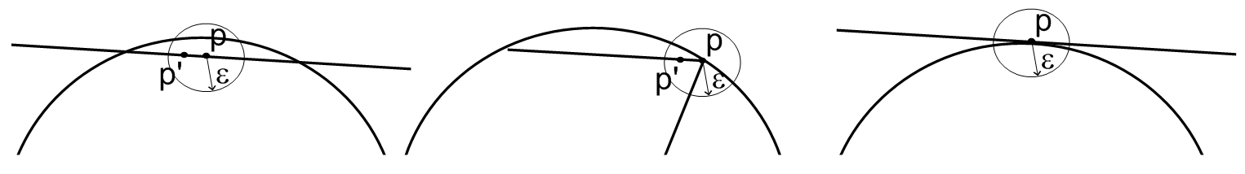
а) b) c)
Figure 1. a) and b) – the relative position of the point and the circle satisfies the condition 1; c) - the relative position of the point and the circle does not satisfy the condition 1.

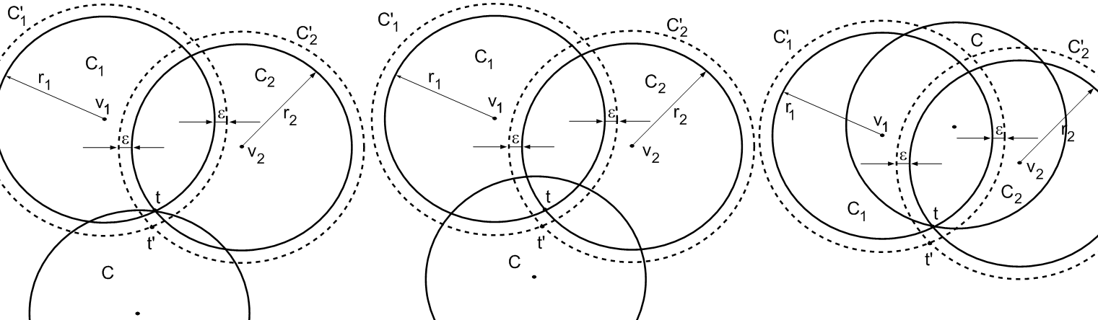
а) b) c)
Figure 2. a) and b) - the relative position of the point and the circle satisfies condition 2; c) - the relative position of the point and the circle does not satisfy condition 2

The problem of covering polygon by circles. Mathematical model of the problem of circular coverage can be represented as follows:

$\underset{u∈W}{\text{extr}}F(u)$, (1)
where
$W=\left\{u∈R^{3N}:Ξ^{'}(u)intersectP=∅\right\}$ (2)

As a criterion of covering for a fixed $u$ can be used phi-function method[14]:
,
where – phi-function of objects $Ξ^{'}(u)$ and $P$ [19].
Since the description of admitted region of the form (2) in an analytical form is extremely difficult theoretical problem and requires significant computational cost, in this study we propose the coverage criteria based on the following statement.
We say that a relative position of the circle $C$ and the points $p∈\text{frP}$ satisfies the condition 1, if $p∈C$ and for any arbitrarily small $ε>0$ in $ε$-neighborhood of the point $p$ there is a point $p^{'}$ such that $p^{'}∈\text{frP}$ and $p^{'}∈C$. Here $\text{frP}$ – the boundary of the set $P$ (Figure 1.).

We say that the relative position of the intersection point $t$ of circle $C_{1}$ and $C_{2}$with the centers in the points $v_{1}$ and $v_{2}$ radius $r_{1}$ and $r_{2}$ with the circle $C$ satisfies condition 2, if $t∈C$ and there is a positive number $δ$ such that for any arbitrarily
small strictly positive $ε<δ$ intersection point $t^{'}$ of circles $C_{1}^{'}$ and $C_{2}^{'}$ and radius $r_{1}+ε$ and $r_{2}+ε$

with centers in points $v_{1}$ and $v_{2}$ also belongs to the circle $C$ (Figure 2).
Note that if $t∈\text{int}C$, the relative position of the point of intersection $t$ and the circle $C$ satisfies the second condition.
Statement. In order $Ξ(u)$ to cover the polygon $P$, it is necessary and sufficient that the vector $u=(v_{1},r_{1},\text{.}\text{.}\text{.},v_{N},r_{N})$ satisfies the condition:
1) for each vertex $p_{k}$ of the polygon $P$ there is at least one circle $C_{i}$ such that their relative position satisfies the first condition (Figure 3);

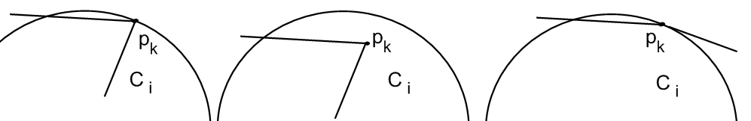

а) b) c)

Figure 3. Three types of the relative position of the vertex of the field and the circle, which satisfy the first item.

2) for any point $t∈{\text{frC}}_{i}intersect\text{frP}$, the relative position with the circle $C_{i}$ satisfies the first condition, there is a circle $C_{j},i≠j$, which the relative position of the point also satisfies the first condition (Figure 4);

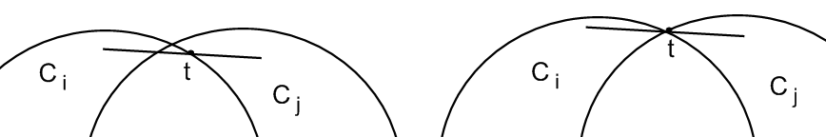

Figure 4. Two types of relative position of the intersection point of the circle with the field and the circle for the item 2).

3) for each point $t={\text{frC}}_{i}intersect{\text{frC}}_{j}$, $t∈\text{frP}$ exists $C_{s},s≠i,s≠j$, such that the relative position of the point $t$ and the circle $C_{s}$ satisfies the second condition (Figure 5);

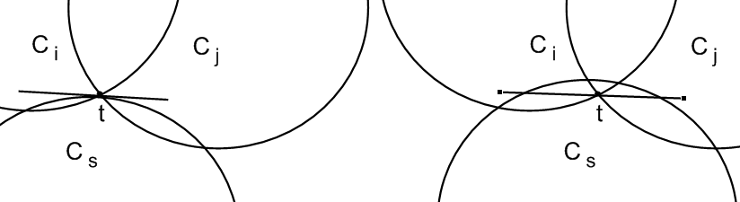

Figure 5. Two types of relative position of the intersection point of circles and the circle for the item 3).

4) for each point $t_{q}={\text{frC}}_{i}intersect{\text{frC}}_{j}$, $t_{q}$, $q=1,2$ $i≠j$, there are $C_{s},s≠i,s≠j$, such that the relative position and $C_{s}$ satisfies the second condition (Figure 6).

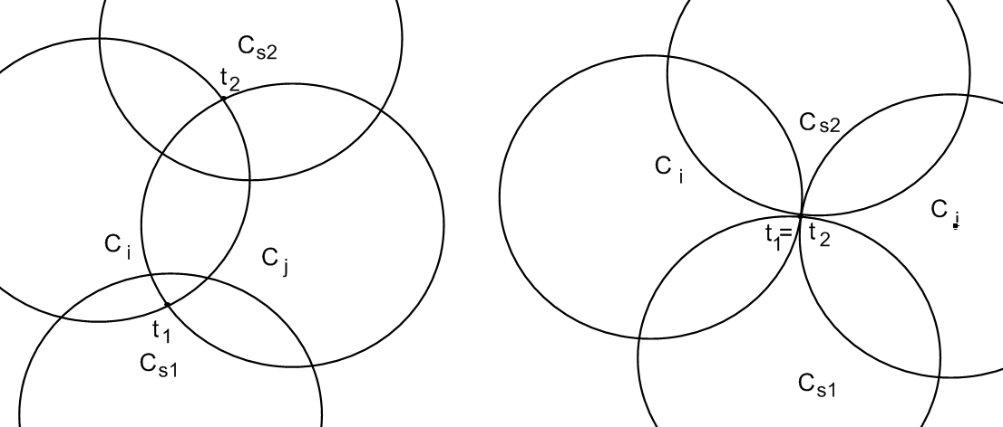

а) б)

Figure 6. Two types of relative position of the intersection point of circles and the circles for the item 4).

Note 2. Further when forming set of constraints for the problem to item 4, we do not take into account two circles for which both points $t_{q}$, $q=1,2$, belong to inner part of the circle $C_{s}$, since taking into account these conditions appear to be excessive.
Note 3. It is assumed that for item 4 the points $t_{q}$, $q=1,2$ are different and even in the case of their superposition (circles $C_{i}$ and $C_{j}$ are contiguous) each of them belongs to its circle (Figure 6b).
Items 1 – 4 can be rewritten in the equivalent form
1) $∀p_{k}$$k∈I_{n}$, exists such circle $C_{i}$, that $p_{k}∈C_{i}$, $C_{i}⊄P$.
2) If there is a point $t∈{\text{frC}}_{i}intersect\text{frP}$, $C_{i}⊄P$, then there are a circle $C_{j}$ and a point $v_{\text{ij}},i≠j$, such that $v_{\text{ij}}∈C_{i}$, $v_{\text{ij}}∈C_{j}$, $v_{\text{ij}}∈R^{2}\text{\backslash int}P$;
3) if there is a point $t={\text{frC}}_{i}intersect{\text{frC}}_{j}$ and wherein $t∈\text{frP}$, there is $C_{s}$ and a point $v_{\text{ijs}},s≠i,s≠j$, such that $v_{\text{ijs}}∈C_{i}$, $v_{\text{ijs}}∈C_{j}$,$v_{\text{ijs}}∈C_{s}$;
4) If there is a point $t_{q}={\text{frC}}_{i}intersect{\text{frC}}_{j}$ and $t_{q}∈\text{int}P$, $q=1,2$,$i≠j$, then there is a circle $C_{s}$ and a point , such, that , ,.

On the figure 7 there is an example of a polygon coverage by the set of circles with the points of type $v_{\text{ij}},v_{\text{ijs}},v_{\text{ijs}1},v_{\text{ijs}2}$.

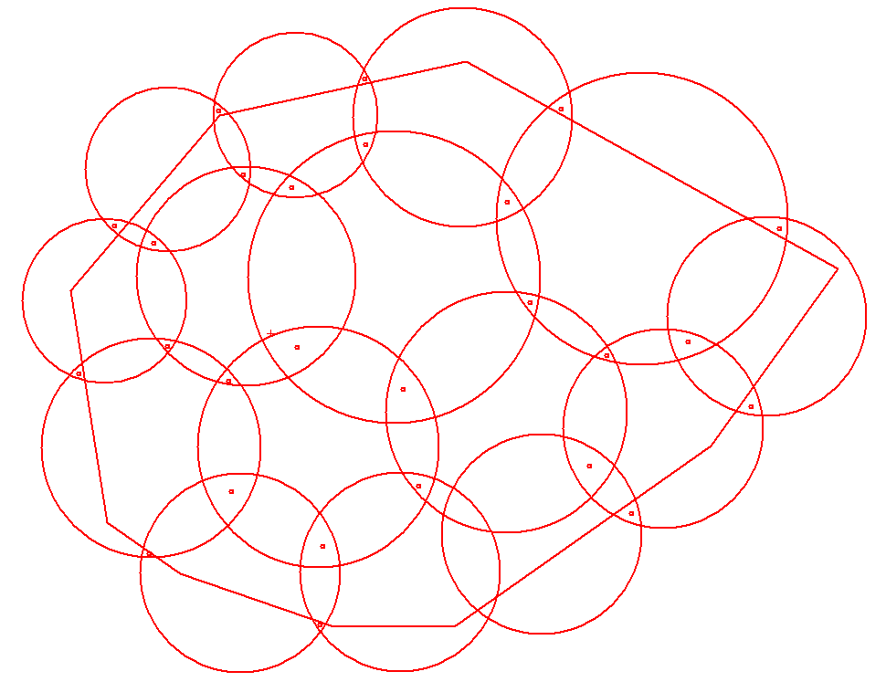

Figure 7. Example of coverage by circles with system of auxiliary points.

With this in mind, the inequalities describing the admitted region of the problem based on the information about the start point can be written as:

1) for the vertices of the polygon $∀p_{k}$$k∈I_{n}$, and the corresponding circles $C_{i}$, $p_{k}∈C_{i}$, $C_{i}⊄P$, inequality:

,

(3)

2) for points $t∈{\text{frC}}_{i}intersect\text{frP}$, circles $C_{i}⊄P$ and the corresponding circles $C_{j}$ – the inequalities system in the form

,

, (4)

where – the membership function of the set $R^{2}\text{\backslash int}P$of points (maximum of $k$ linear functions);
3) for points $t={\text{frC}}_{i}intersect{\text{frC}}_{j}$, $t∈\text{frP}$ and the corresponding circles $C_{s}$– the inequalities system in the form

,

, (5)
4) for points $t_{q}={\text{frC}}_{i}intersect{\text{frC}}_{j}$ and $t_{q}∈\text{int}P$, $q=1,2$,$i≠j$ and the corresponding circles – the inequalities system in the form:

, (6)
and

,
. (7)

Thus, the mathematical model of the problem coverage area can be formulated as a problem of local optimization

(8)

in the area of feasible solutions , taking into account the limitations of the system (3)-(7).

Here ,- cardinality of the set , - set of indexes of pairs of numbers of vertices polygon and circles, satisfying the conditions of paragraph 1 of the criterion of the existence of covering the polygon by the circles, - set of indexes of pairs of numbers of vertices polygon and circles, satisfying the conditions of paragraph 2 of the criterion of the existence of covering the polygon by the circles, - set of indexes of pairs of numbers of vertices polygon and circles, satisfying the conditions of paragraph 3 of the criterion of the existence of covering the polygon by the circles, , - set of indexes of triples of numbers of vertices polygon and circles, satisfying the conditions of paragraph 4 of the criterion of the existence of covering the polygon by the circles, , ; , , – the coordinates of auxiliary points that are used to formalize the terms of covering.
Search of local optimal solution is performed using nonlinear of package of open source IPOPT. It should be noted that at the last iteration of the algorithm point of local extremum in the subregion is the points of local extremum of the initial problem.
Given a starting point - a vector , in which is a covering (Fig. 8a).
It is necessary to define a vector , in which is a covering , and the radii of the circles have reached the minimum value (at zero - the circle is removed). On fig.8b is an example of problem solving.
CONCLUSIONS
The constructed model of covering the polygon by the circles of variable radii and a method for obtaining local extremum is basic for a wide range of practical problems, in particular for the problem of locating points of video surveillance, which arises when designing ground video monitoring systems, as well as automatic fire protection systems [20 – 21].

.

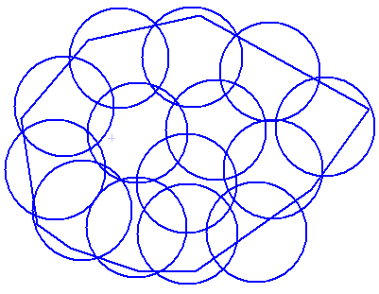

а)

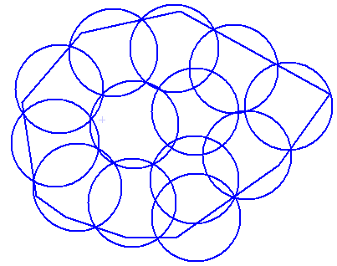

b)
Figure 8. Covering of polygon by circles
a)the initial covering of area; b) optimization result

REFERENCES

1. Стоян Ю.Г. 1983. Основная задача геометрического проектирования / Ю.Г. Стоян. – Х.: Ин-т проблем машиностроения АН УССР – 1983. – 36. (Препринт/ АН УССР. Ин-т проблем машиностроения; 181.). In Russian.
2. Яковлев С.В. 1995. Элементы теории геометрического проектирования. / [Яковлев С.В., Гиль Н.И., Комяк В.М. и др.]; под ред. В.Л. Рвачева. – К.: Наук. думка, 1995. – 241. In Russian.
3. Rvachev V.L. 1963. On the analytical description of some geometric objects”, Reports of Ukrainian Academy of Sciences, vol. 153, no. 4, 765–767. In Russian.
4.Rvachev V. L. 1982. Theory of R-functions and Some Applications. Kiev: Naukova Dumka. In Russian.
5.. Rvachev V.L., SheikoT.I. 1995. R- functions boundary value problems in mechanics, Appl. Mech. Rev, 48, N4, 151-188. In Russian
6. Panishev A., Levchenko A., Matsiy O. 2010. Optimization of Closed Routes for Transport Network // Artificial intellect. №1, 43-49. In English.
7. Popov V., Chub I., Novozhylova M. 2015. The optimal structure for territorial technogenic safety system // Econtechmod an international quarterly journal, Vol.4, No.3, 79-84.In English.
8. Стоян Ю.Г. 1986. Математические модели и оптимизационные методы геометрического проектирования / Ю.Г. Стоян, С.В. Яковлев. – К.: Наук. Думка. – 265. . In Russian.
9. Романова Т.Е. 2005. Метод покрытия прямоугольника конгруэнтными кругами с учётом дополнительных ограничений / Т.Е. Романова, А.В. Панкратов, В.Н. Пацук, С.Б. Шеховцов // Радиоэлектроника и информатика. – № 1. – 48-51. In Russian.
10. Антошкин А.А. 2001. Задача покрытия прямоугольной области кругами заданного радиуса / А.А. Антошкин, А.В. Панкратов, В.Н. Пацук та ін. // Радиоэлектроника и информатика.– № 3. – 38 - 41. In Russian.
11. Панкратов А.В. 2002. Метод регулярного покрытия прямоугольной области кругами заданного радиуса / А.В. Панкратов, В.Н. Пацук, Т.Е. Романова, А.А. Антошин // Радиоэлектроника и информатика.–№ 1. – 50 - 52. . In Russian.
12. Злотник М.В. 2007. Стратегия решения задачи покрытия многосвязной многоугольной области / М.В. Злотник, А.В. Кривуля, А.В. Панкратов, Т.Е. Романова // Бионика интеллекта.– 2(67). – 51–55. In Russian.
13. Фейеш Тот Л. 1958. Расположения на плоскости, на сфере и в пространстве / Фейеш Тот Л. – М.: Физматгиз.. – 363. In Russian.
14. Fejes Tot G. 1979. Multiple packing and covering of spheres / Fejes Tot G. // Acta Math. Acad. Sci. – Hungar. – V.34. – №1 – 2. – 165 – 176. In English.
15. Конвей Дж. 1990. Упаковка шаров, решетки и группы / Дж.Конвей, Н. Слоен. – М.: Мир.– Т. 1– 2. In Russian.
16. Drezer Z. 1984. The p-centre problem – heuristic and optimal algorithms / Z. Drezer // J.OR Soc.– V.35. – 741-748. In English.
17. Собина В.О. 2010. Особливості методу визначення раціональної кількості та місць розташування оперативних підрозділів для захисту об’єктів залізниці / В.М. Комяк, О.М. Соболь, А.Г. Коссе, В.О. Собина // Проблеми надзвичайних ситуацій. Зб. наук. пр. НУЦЗ України. – Харків: НУЦЗУ. – Вип.11. – 74-79. In Russian.
18. Комяк В.М. 2014. Оптимизация размещения пунктов наблюдения наземних систем видео-мониторинга лесных пожаров / В.М. Комяк, А.В.Панкратов, А.Ю. Приходько, С.Д. Светличная // Проблемы пожарной безопасности. Сб. науч. тр. НУГЗ Украины. – Харков: НУГЗУ.– Вып.36. – 117-126. In Russian.
19. Стоян Ю.Г. 2010. Полный класс Ф-функций для базовых объектов / Ю.Г. Стоян, Т.Е. Романова, Н.И. Чернов, А.В. Панкратов // Доп. НАН України.– № 12. – 25-30. In Russian.
20. Система «Лесной Дозор». 2011. «Современные технологии мониторинга и тушения лесных и торфяных пожаров» в рамках международной выставки «Пожарная безопасность XXI века», Москва, 13–16 сентября 2011. In Russian.
21. Антошкин А.А. 2001. Особенности построения математической модели задачи покрытия в системах автоматической противопожарной защиты / А.А.Антошкин, В.М.Комяк, Т.Е.Романова, С.Б.Шиховцов // Радиоэлектроника и информатика.– № 1(14). – 75-78. In Russian.

